Library Activity #1

Wed., April 8th

Easter Theme
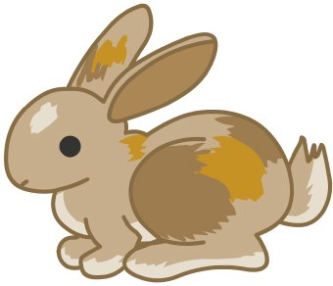
This Photo by Unknown Author is licensed under CC BY-ND

PreS – 2nd grade

Read/Listen to the following story:

Story: Duck! Rabbit!

Go to: www.tumblebooklibrary.com
- Sign In (upper right hand of the screen)
  - Username: sageland
  - Password: reads
- Click on TumbleSearch (upper right of the screen)
- In Search by Title, type: Duck! Rabbit!
- Press Go
- Click on the book icon or click on Play Video
- Enjoy!

View/Listen to the Non-fiction Video: Rabbit Roundup
- https://watchandlearn.scholastic.com/videos/animals-and-plants/all-kinds-of-animals/rabbit-roundup.html

Select one or both craft activities:
Craft Activity #1: Bunny Ears
https://www.youtube.com/watch?time_continue=2&v=CWz2aoowYnc&feature=emb_logo
You will need:
- White Paper
- Pink Paper (Instead of pink paper, students can color the ears with a marker/crayon)
- Scissors
- Crayons/Markers

Craft Activity #2: Stuffed Bunny!
http://www.hellokids.com/c_32692/kids-crafts-and-activities/easter-crafts/diy-easter-sock-bunny
You will need:
- Permanent Marker
- Scissors
- Old, long sock
- Yarn
- Large Packaging Tape
- Rice

You can post a picture of your bunny ears or stuffed bunny in your Teachers’ ClassDojo and/or add them here on the right had side of the screen where it says + Add or create. Then select File and then click on Select files from your device. Pick your pictures and then click Upload. Make sure to click on the blue button that says “Turn In”! or your teacher won’t get your pics!

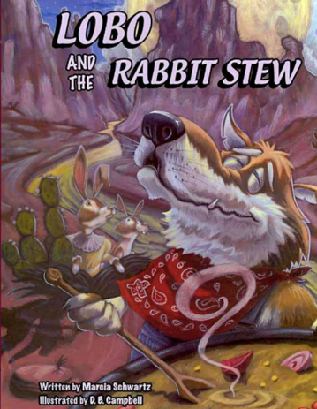
3rd – 6th grade

Activity: Compare & Contrast: Text-to-Text

Title:
Compare & Contrast: Text-to-Text: ‘Lobo & the Rabbit Stew’

Instructions:
Go to Tumble Books: www.tumblebooklibrary.com
Sign in (upper right hand of the screen)
Username: sageland
Password: reads
Then, click on TumbleSearch (upper right hand of the screen)
In the box that says Search by Title, “Lobo and the Rabbit Stew” (must have correct spelling!)
Click on Go
Click on the book icon or click on Play Video
Enjoy the story keeping in mind that you’re going to do a compare/contrast to another text of your choice!
After listening to the story, click on the Doc link below and complete the text-to-text assignment.
Submit your work on the right-hand side of the screen by clicking on +Add or create button.
Select Google Drive and find your work and select it. Then click on the Add button.
Make sure to Click on the blue “Turn In”! button afterwards, or your teacher will not get your work! The “Turn In” button is like a Submit button!

Students, if your teacher does not have this activity in her/his Google Classroom, you can go to my Library Google Classroom and look for the assignment there: “Compare & Contrast: Text-to-Text: Lobo & the Rabbit Stew” And then follow the instructions above.
If you don’t have my Library Google Classroom, the code is: izrhnxt

