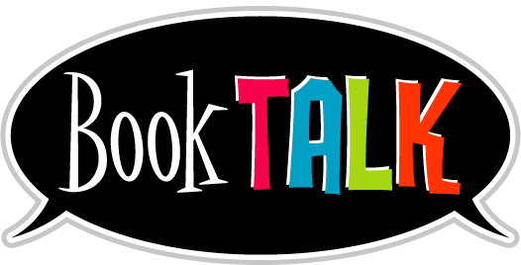
Library Activity #2

(Wed., April 15th)

PreS – 6th grade

This week, you can create a BookTalk where you can record yourself on FlipGrid and talk about a book you have read. This FlipGrid is for the entire school, so you’ll be able see videos from all different grade levels! This FlipGrid BookTalk will always be available, if you wish to continue uploading BookTalks as the days go by, especially if you find a good book you recommend for others to read. We all like to know which are the good stories!

Instructions:
(If this is your 1st Flipgrid video, click on the how-to video below called ‘Getting Started Student on Vimeo’ to get you started on your video. You can refer to the step-by-step instructions below, as well. The instructions below include a little more than what the how-to video does.)

(Note: What you need to include in your BookTalk is in the FlipGrid link below.)

Here is how to get into the FlipGrid BookTalk and create your video:
Click on the link: https://flipgrid.com/d108b350
Then, select ‘Log In with Google’
Select your YISD email account
Click on the big Green Plus button
You can add many things such as filters, text, stickers, etc. before recording.
The, record your video and press ‘Next’.
If you want to add more to your video, you can or if you did not like your video, you can press on the X button on the upper left-hand side and click Confirm or press Redo. You can rerecord yourself until you like your video.
Once you like your video, click on the ‘Next’ button again.
It’ll ask you to take a Selfie and you can add stickers among other things. You can redo your selfie, too, until you like it.
Once you like your picture, press Next.
In the ‘Display Name’, write your First Name Only.
In the ‘Title’, write the title of your book.
In the ‘Link’, put a link to your book, if you have one, so other students can check out your book.
Once you’re finished, click ‘Submit Video’.
If you wish, you can download your video and selfie to your computer!
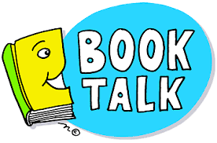
Then, after downloading, click on ‘Complete’.
Enjoy seeing other students’ BookTalks!

How-To: Getting Started Student on Vimeo
https://vimeo.com/398016659

