Library Activity #5

(Wed., May 6th)

You will submit your picture(s) to your teacher either thru ClassDojo, emailing him/her, or any other way you communicate with your teacher.

Plus, share your pictures with me at: https://padlet.com/mmadrid5/mothersday2020

Stories: PreS – 6th grade

Instructions:
Select any story you’d like to read/listen to. You are more than welcomed to hear more than one of them:

- The Kissing Hand: https://www.storylineonline.net/books/kissing-hand/
- Love you Forever: https://www.youtube.com/watch?v=70aHBZEbrxo
- The Runaway Bunny: https://www.youtube.com/watch?v=kj3c99efFsA

Craft: PreS – 6th grade
Instructions:
Select any of the following crafts to make for Mother’s Day. You are welcomed to make more than one:

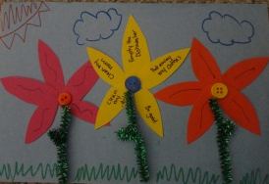
1. Flower Petal Coupon Card
What you'll need:
- Glue
- Scissors
- Markers
- Colored construction paper or white paper and color your petals
- 3 Buttons (if you have any, but not necessary; just color a circle in the middle of your flowers)
- 1 green pipe cleaner (if you have any, but not necessary; just draw and color the stems and leaves on your flower)
How to make your Flower Petal Coupon Mother’s Day Card
- Fold a piece of cardstock in half to form the card.
- Using scissors, cut 15 small flower petals from colored paper or use white paper and color your petals. Glue them in groups of five to the center of the paper to form 3 flowers. Allow the glue to dry.
- Glue a button to the center of each of each flower or draw a circle and color it. Cut the pipe cleaner into three pieces or draw and color your stems and leaves. Glue a pipe cleaner to the bottom of each one for the stem. Allow the glue to dry.
- Using markers, decorate the flowers and background of the card. On each of the petals, write a different chore or promise to your mom. Some ideas include putting away the dishes, making her bed or your bed, being good, or cleaning your room without being asked, etc.
Your card is complete! Don’t forget to give your mom a big hug and kiss when you give her your card on Mother’s Day!

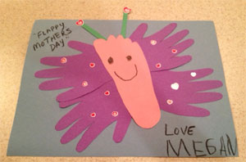
2. Foot & Handprint Butterfly Card
What you'll need:
- Construction paper or white paper and just color your foot and hands
- Scissors
- Crayons
- Stickers or any other decorative items
How to make your Foot and Handprint Butterfly Card:
- Trace your handprint onto construction paper/white paper and make 4 copies. Color your hands if using white paper.
- Trace your footprint onto construction paper/white paper and cut it out. Color your foot if using white paper.
- Glue the handprints to the footprint, two on each side to make wings.
- Glue the butterfly to a full sheet of construction paper/white paper.
- Add small rectangles for antennae.
- Draw a face and decorate the butterfly.
- You can write "You make my heart soar!" or "Thank you for helping me fly!" on the card and write your name.
Your card is complete! Don’t forget to give mom a big hug and kiss when you give her your foot and handprint butterfly card!

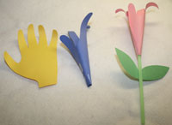
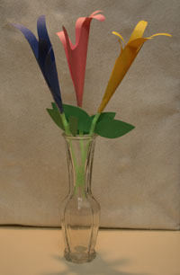
3. Handprint Flowers Gift
What you'll need:
- Construction paper (many colors)
- Scissors
- Tape
- Glue
- Pencil, Crayons, Markers
- Straws or Rolled Green Construction Paper
How to make your Handprint Flower Gift:
- Trace your hand on the construction papers. Make sure that you trace a little bit of the wrist! And cut out the handprints.
- Use a pencil or marker and roll each finger around it to create a little bit of curl.
- Lay the handprint on the table so the fingers curl out towards the table. Pick up the flower, wrap it around, and tape the ends together at the wrist section.
- To make the stem, either tape end of the flower around a green straw, or tightly roll a piece of green construction paper and tape or glue the flower to that.
- Cut leaves out of green construction paper and tape or glue them to the stem (if using a straw, tape works better).
Make as many as you’d like and give them to Mom on her special day! Don’t forget a hug and a kiss!

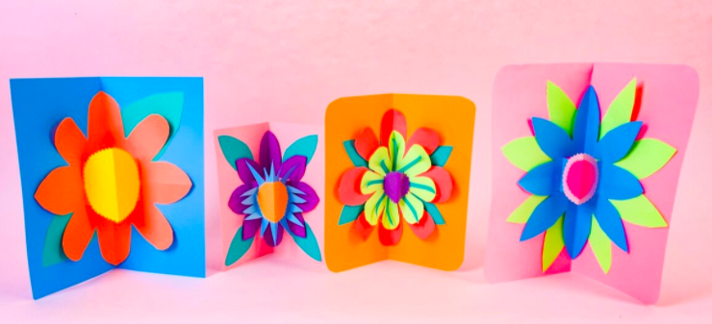
4. Mother’s Day Pop-Out Card

What you’ll need:
- 3 sheets of construction paper or white paper and color your petals and leaves
- Scissors
- Optional: fun-shaped scissors
- Glue
INSTRUCTIONS:
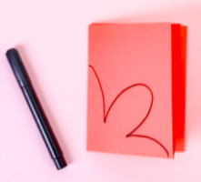
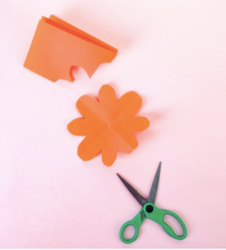
- Fold a sheet of construction paper or white paper in half and in half again. From the folded corner, draw a flower petal with two half-petals on either side.
- Cut the petal shapes out and unfold the paper to reveal a beautiful, symmetrical flower. If using white paper, color the petals.
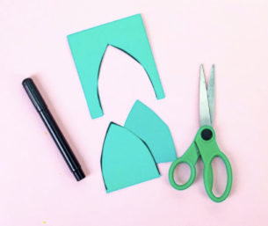
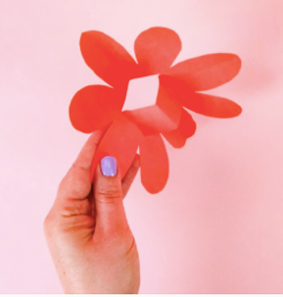
- Fold the flower in half and cut 2 slits up from the folded edge at the center of the flower. Open up the flower and push in the square shape so that it folds away from the flower.
- Cut out some leaf shapes for your flower using green construction paper. If using white paper, color your leaves.
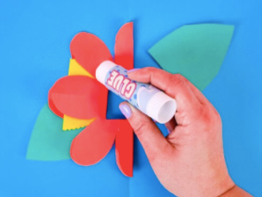
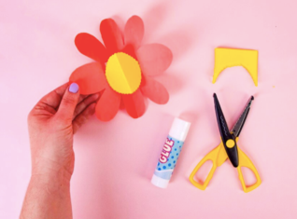
- Cut out a circle to make the center of your flower by folding some yellow construction paper in half and cutting a semi-circle. If using white paper, color your paper yellow. You can use your fun shape scissors, if you have any, but it is not necessary. This circle will cover the pop-up square that you made in the center of your flower, so make sure it’s big enough to glue down and cover the edges.
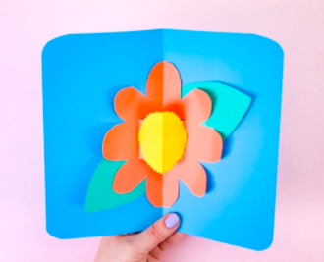
- To make your card, fold a piece of construction paper in half or white paper. Place your flower inside the card and glue down the leaves and petals.
- You can curl the petals delicately to add a 3D effect.

Write a beautiful message on the card for your mother and give it to her on her special day! Don’t forget to give her a hug and a kiss, too!

You can submit your picture(s) to your teacher either thru ClassDojo, emailing him/her, or any other way you communicate with your teacher.

Plus, share your pictures with me at: https://padlet.com/mmadrid5/mothersday2020

