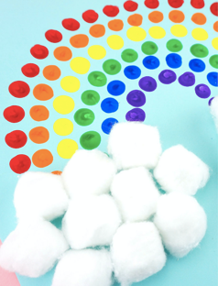
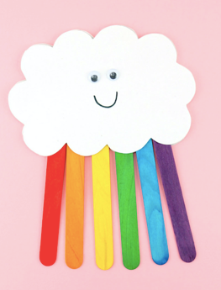
Library Activity #5

(Wed., May 13th)

You will submit your picture to (make sure you come out in the picture or write your first & last name and your teacher’s name on your craft):

https://padlet.com/mmadrid5/libraryactivity6

PreS – 2nd grade

Read/Listen to 1 of the following stories, or both (your choice):

Story #1: The Rainbow Fish: https://www.storylineonline.net/books/the-rainbow-fish/
Story #2: A Bad Case of Stripes: https://www.storylineonline.net/books/a-bad-case-of-stripes/

3rd – 6th

Listen to the following video & hopefully you like the other science videos there:
Science Video: How is a rainbow made?: https://mysterydoug.com/mysteries/rainbows?code=f52e12fa9aad25a4ef2431166cb4be37

Crafts: PreS – 6th
You are welcome to make your rainbow any which way you want/can!
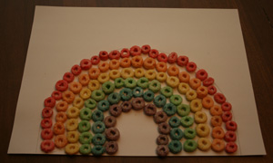
But here are two crafts you can do:

Craft Activity #1: Fruit Loops Rainbow!

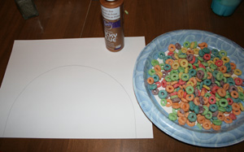
You will need:
- Fruit Loop Cereal,
- White Elmer’s glue,
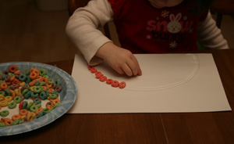
- White paper,
- Flat paper/plastic plate,
- Pencil

How to make your Rainbow:
- Draw a rainbow line on the paper or construction paper.
- Pour some cereal onto a flat plastic/paper plate (it is easier to see the fruit loop colors than in a bowl).
- Put a line of glue around the outside edge of the rainbow. Have your child place red fruit loops on this line.
- When they are done with the red line, put down another line of glue just to the inside of the red row and have them put down orange fruit loops.
- Repeat this process for the remaining colors (in order: yellow, green, blue, purple) (this is the color order of a rainbow)

Post your picture to (make sure to include yourself in the picture or write your first & last name and your teacher’s name on your craft):: https://padlet.com/mmadrid5/libraryactivity6

Craft Activity #2: Make Your Foil Colorful!!!
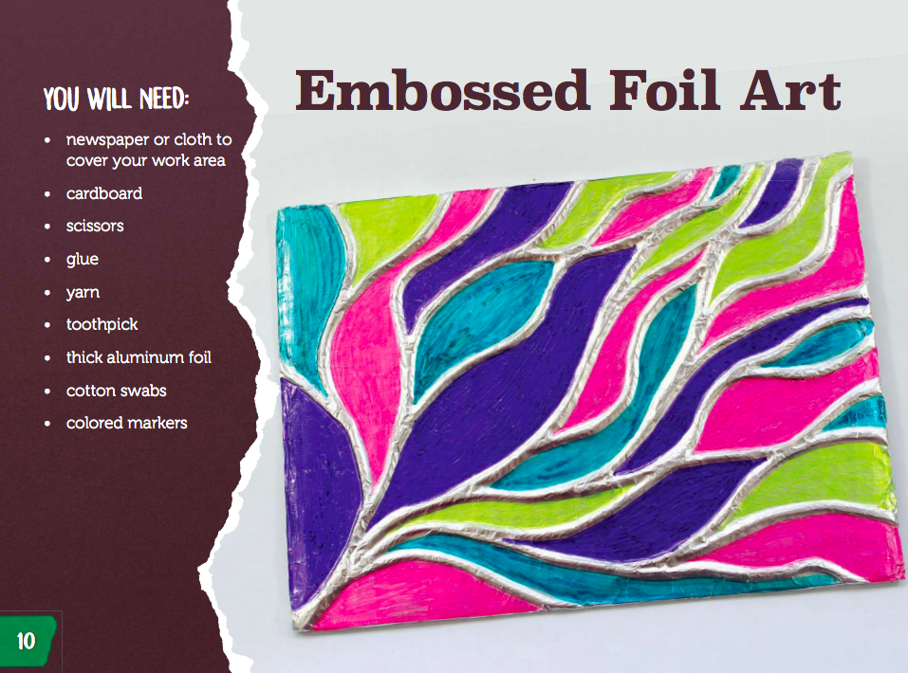
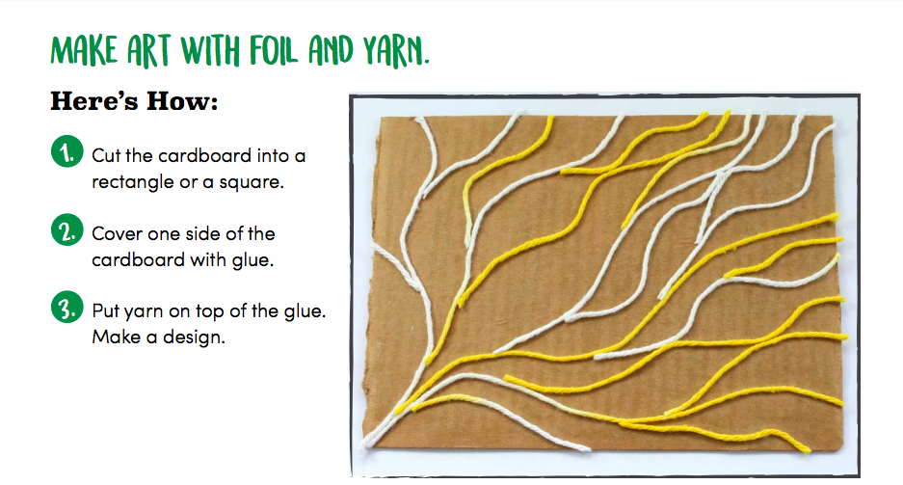

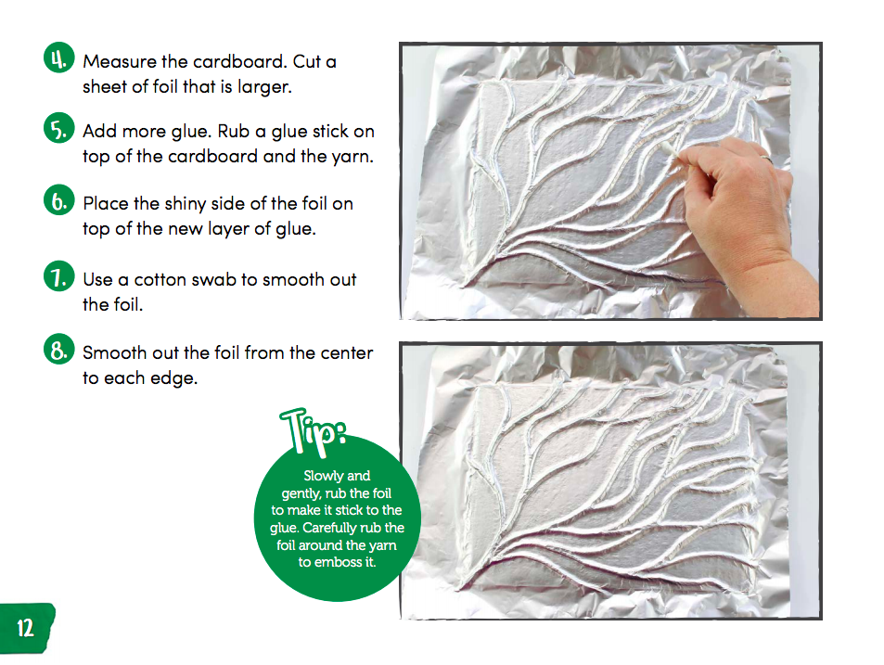

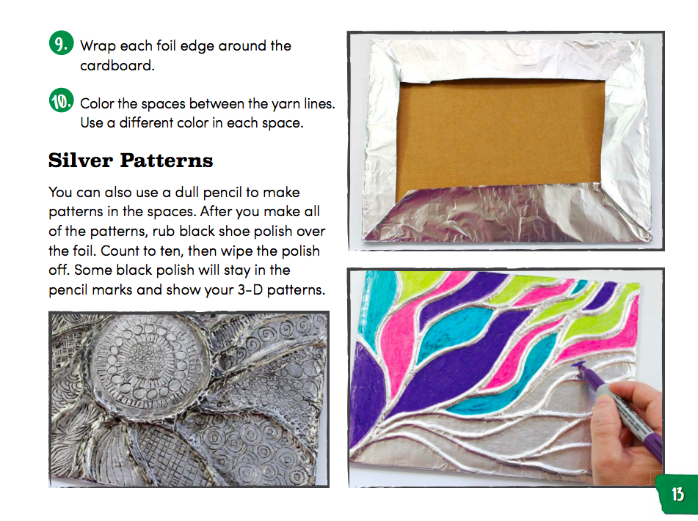

Post your picture to (make sure to include yourself in the picture or write your first & last name and your teacher’s name on your craft): https://padlet.com/mmadrid5/libraryactivity6

