Online GT Lesson #1
“Sustainability”
(4/6/20 – 4/17/20)

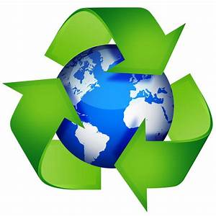
Sustainability is about making a conscious
effort to meet the needs of the present without
compromising future generations.

Sustainability goes beyond basic recycling to build
thoughtfulness into our choices about how we
treat our environment.

Instructions:

Go to www.my.yisd.net

Sign in with your school username & password

If you’re asked if you’d like to stay signed in, say yes.

Click on Clever

Log in with Active Directory

Scroll down and click on Gale Databases

Scroll down and click on Kids InfoBits

In the search bar, type ‘Sustainability’

Listen to the first two videos

Then go back to clever and select Gale Database again

Scroll down and select National Geographic Kids

In the search bar, type ‘Sustainability’

Watch the first video

Then watch the attached the following videos below:
- https://www.youtube.com/watch?v=DZLbhuMiJXg
- https://www.youtube.com/watch?v=7V8oFI4GYMY

After learning about sustainability through various resources to get a good grasp about the concept, select one of the following topics to research:

Sustainable schools or homes (Del Valle Elementary is a green school in our district!)

Companies that reuse/recycle/reduce materials to make their products or provide their services

Green environmental technologies that exist and those that are being developed for the future

Innovative disposal and recycling solutions/plans

Careers in waste or environmental management, and what they do, how much they earn, and what level of education do they need.

The impact on the environment with the decrease of human activity due to COVID19 (china’s air pollution went down from people not driving and going about their daily routines!)

Effects of changes in ecosystems caused by humans

Effects of changes in air quality (air pollution) caused by humans

What effects have humans had on ocean pollution?

What have been the effects of over-population on Earth and, if we don’t reach sustainability, how will Earth be like in the future?

11. What have been the effects of our over consumption of natural resources such as overfishing, using too much water, and over-use of fossil fuels?

Before looking into the Internet, take a look into Britannica’s Online Encyclopedia by going to: www.school.eb.com . The Username is: sage Password: scotties .

After learning about your topic and jotting information down, go to your YISD Clever again and scroll down and look for Canva. In Canva, you can create so many different things, but for this research assignment, you will do an Infographic. Select any template you’d like. You can view the template bigger by clicking on --% percent sign on the bottom and selecting a bigger percent. Make sure to include a link to a video that talks about or explains your topic. Input all your information into your Infographic and when you’re done making it good, you will click on Download and then select PDF high quality. Then press Download again.

Go to my GT Google classroom. The code is: 2aceodi Then click on the assignment called Sustainability, and turn in your Infographic on the right-hand side of the screen where it says ‘+ Add or create’. Select File. Then, click on ‘Select Files from your device’. And double click on your Infographic. Click Upload. Remember to click on the ‘Tun In’ button (this is like a Submit button) or your work will not be submitted! Please click on ‘Turn In’ again. Now you’re done!

Hope you learned about our world and the need to take care of it so that future generations can enjoy it!

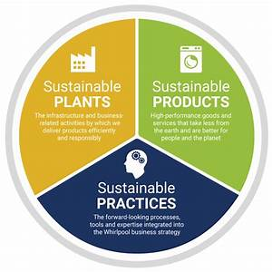

If you need any help or get stuck somewhere, you can send me a private message to your right hand side or email me at:

mmadrid5@yisd.net

