Online GT Lesson #2
“Endangered Plants”
(4/20/20 – 5/1/20)

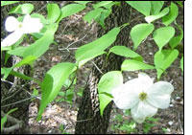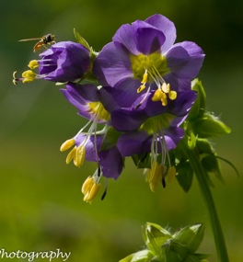

For this GT project, you will research endangered plants, not endangered animals!

Animals aren’t the only species currently endangered. We are losing lots of plants, too!
We have endangered plants in Texas and the County of El Paso, as well!

(In the GT Google Classroom assignment, you will find in the assignment an attached poster & a list of the endangered species in our state and our county.)

Instructions:
- Go my GT Google Classroom. The code is: 2aceodi
- Read thoroughly the instructions in the assignment titled “Endangered Plants” before you get started.
- This project is due: May 1st.

