Online GT Project #3
“Past Worldwide Pandemics”
(5/4/20 – 5/15/20)

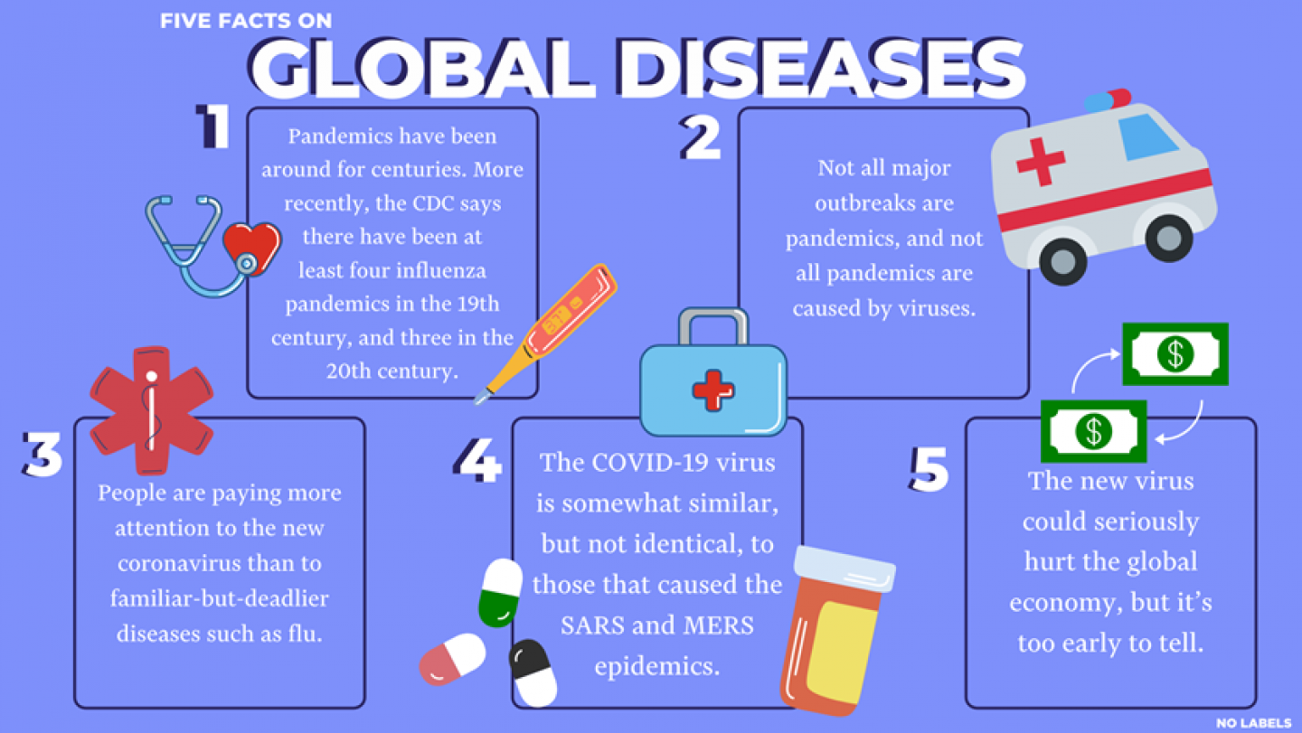

For this GT lesson, you will research any past pandemic of your choice, or you could research about the current one.

*For 3rd - 6th grade students: First start by reading/listening to this letter from the Global Wildlife Conservation in which they write a letter from the point of view of the COVID-19 virus and the virus is speaking to us. It makes you ponder: https://www.globalwildlife.org/blog/dear-humankind/

Go to my GT Google Classroom and follow the instructions there. The class code is: 2aceodi

This is your last GT project.

Wishing everyone a healthy & safe summer!

