Library Activity #7

(Wed., May 20th)
You will be taking a picture of yourself with your Memorial Day poppy flowers and posting your picture at: https://padlet.com/mmadrid5/memorialday2020

(Memorial Day this year will be Monday, May 25th)

PreS – K
Memorial Day Poppy Song for Kids
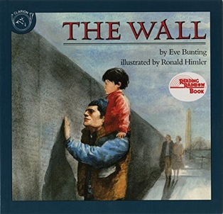
https://www.youtube.com/watch?v=tKYBsdcVJNg

1st – 6th
THE WALL. By: Eve Bunting
https://www.youtube.com/watch?v=5k3mFMvzCYc

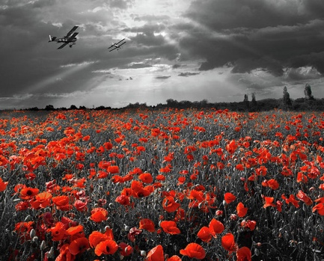
Crafts: PreS – 6th
The wearing of red poppies is in honor of those who have died in battle on Memorial Day. The red poppy was one of the first plants to grow after the battles of World War I. The red poppy is a symbol of both Remembrance and Hope for a Peaceful Future. It also symbolizes the blood shed during the battles. So, Americans wear red poppies to commemorate the sacrifice of so many men and women who have given their lives for our country. They are not worn on Veteran’s Day because this holiday is to celebrate all living veterans.

Instructions:
- You can select any craft to make your poppies and you can make them any way you can.

- Hang/tape your poppies on a window where people can see them as they walk by, especially neighbors who have lost someone to war.

- You are also welcomed to put your poppies on your front door or wherever you’d like in your front yard.

- Doing this is our way of paying our respect, remembering, honoring, and showing out gratitude for those who have made the ultimate sacrifice and given their lives to protect the country we peacefully live in.

Craft #1: How to Draw Poppies
https://www.youtube.com/watch?v=EkSBztJ_bMQ

Craft #2: Poppy Flower Made Out of Paper
https://www.youtube.com/watch?v=qcphpOKt3fs

Craft #3: How to Make Paper Poppies
https://www.youtube.com/watch?v=LbKjTNMh1QE&t

Craft #4: How to Make Paper Poppies (this video is similar to the one right above)
https://www.youtube.com/watch?v=sk0IJRy17VE

Craft #5: How to Make a Poppy Wreath
https://www.youtube.com/watch?v=jauLkOpeLR8

Take a picture of you with your poppies and post it at: https://padlet.com/mmadrid5/memorialday2020

